XML Schema for Models

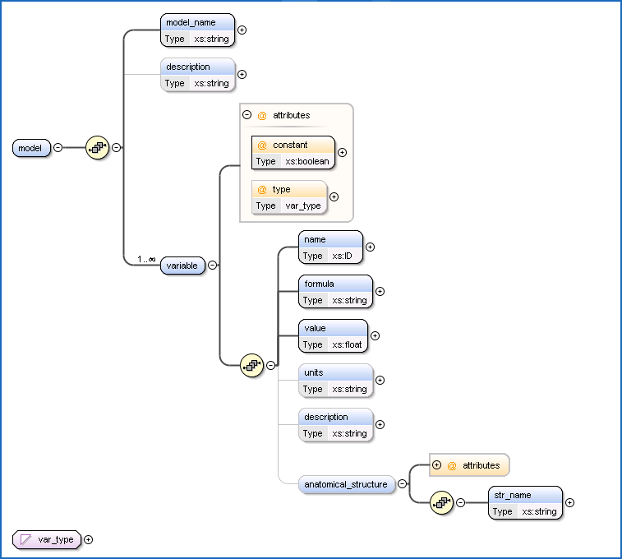

|  |  |
| --- | --- |
| Element | *model* |
| Content/Type | Complex |
| Cardinality | 1..1 (See notes) |
| Parent | N/A |
| Children | *model_name, description, variable* |
| Notes | Root node for the model. Currently, only one model is stored in an XML file. In the future, the schema may change to allow multiple models to be saved in a single file. A model is defined by its name, description, and a collection of variables. |

|  |  |
| --- | --- |
| Element | *model_name* |
| Content/Type | xs:string |
| Cardinality | 1..1 |
| Parent | *model* |
| Children | N/A |
| Notes | The name of the model. Currently set to the file name, but support for naming models will be added to the GUI in the future. |

|  |  |
| --- | --- |
| Element | *description* |
| Content/Type | xs:string |
| Cardinality | 1..1 |
| Parent | *model* |
| Children | N/A |
| Notes | A description of the model. Currently useless, since the GUI doesn’t have any means of displaying/editing it. Optional. |

|  |  |
| --- | --- |
| Element | *variable* |
| Content/Type | Complex |
| Cardinality | 1..∞ |
| Parent | *model* |
| Children | *name, formula, value, units, description, anatomical_structure* |
| Attributes | *constant, type* |
| Notes | A node defining a single variable or parameter. A model must have at least one variable. |

|  |  |
| --- | --- |
| Element | *name* |
| Content/Type | xs:ID |
| Cardinality | 1..1 |
| Parent | *variable* |
| Children | N/A |
| Notes | The name of the variable, which must be unique within the model. The xs:ID datatype is less restrictive than the MML naming requirements, so further validation occurs to ensure compatibility with MML models. This could be eliminated by defining a new datatype constraining the lexical space to valid MML names. |

|  |  |
| --- | --- |
| Element | *formula* |
| Content/Type | xs:string |
| Cardinality | 0..1 |
| Parent | *variable* |
| Children | N/A |
| Notes | The formula defining a variable. Left blank for parameters. |

|  |  |
| --- | --- |
| Element | *value* |
| Content/Type | xs:float |
| Cardinality | 1..1 |
| Parent | *variable* |
| Children | N/A |
| Notes | The value of a parameter; the initial value of a variable. |

|  |  |
| --- | --- |
| Element | *units* |
| Content/Type | xs:string |
| Cardinality | 0..1 |
| Parent | *variable* |
| Children | N/A |
| Notes | Measurement units. Will be used to allow for unit conversion and validation. Optional. |

|  |  |
| --- | --- |
| Element | *description* |
| Content/Type | xs:string |
| Cardinality | 0..1 |
| Parent | *variable* |
| Children | N/A |
| Notes | The description of the variable. Optional. |

|  |  |
| --- | --- |
| Element | *anatomical_structure* |
| Content/Type | Complex |
| Cardinality | 0..1 |
| Parent | *variable* |
| Children | *str_name* |
| Attributes | *FMAID* |
| Notes | The anatomical structure associated with a variable, defined by the structure’s FMAID and name. Used to query for related variables. Optional. |

|  |  |
| --- | --- |
| Element | *str_name* |
| Content/Type | xs:string |
| Cardinality | 1..1 |
| Parent | *anatomical_structure* |
| Children | N/A |
| Notes | The name of the structure. Value depends on the FMAID. |

|  |  |
| --- | --- |
| Attribute | *constant* |
| Content/Type | xs:boolean |
| Usage | *variable* |
| Notes | True for a parameter (formula is blank). If false, the variable’s formula must be defined. Required. (This is a bit of a kludge.) |

|  |  |
| --- | --- |
| Attribute | *type* |
| Content/Type | var_type |
| Usage | *variable* |
| Notes | The variable type, as defined in the MML spec. Default value is “real” (currently hardcoded for all variables when saving the model). Required. |

|  |  |
| --- | --- |
| Attribute | *FMAID* |
| Content/Type | xs:int |
| Usage | *anatomical_structure* |
| Notes | An anatomical structure’s FMAID. Required. |

|  |  |  |
| --- | --- | --- |
| Type | *var_type* | |
| Content/Type | restriction of xs:string | |
| Facets | Facet Type | Value |
| Enumeration | realDomain |
| Enumeration | real |
| Enumeration | int |
| Usage | *type* | |
| Notes | See attribute info. | |

model_schema.xsd

<?xml version="1.0" encoding="utf-8"?>

<xs:schema id="model_schema" targetNamespace="http://tempuri.org/model_schema.xsd" elementFormDefault="qualified" xmlns="http://tempuri.org/model_schema.xsd" xmlns:mstns="http://tempuri.org/model_schema.xsd" xmlns:xs="http://www.w3.org/2001/XMLSchema">

<xs:element name="model">

<xs:complexType>

<xs:sequence>

<xs:element name="model_name" type="xs:string">

</xs:element>

<xs:element name="description" type="xs:string" minOccurs="0">

</xs:element>

<xs:element name="variable" maxOccurs="unbounded">

<xs:complexType>

<xs:sequence>

<xs:element name="name" type="xs:ID" />

<xs:element name="formula" type="xs:string" />

<xs:element name="value" type="xs:float" />

<xs:element name="units" type="xs:string" minOccurs="0" />

<xs:element name="description" type="xs:string" minOccurs="0" />

<xs:element name="anatomical_structure" minOccurs="0">

<xs:complexType>

<xs:sequence>

<xs:element name="str_name" type="xs:string" />

</xs:sequence>

<xs:attribute name="FMAID" type="xs:int" use="required" />

</xs:complexType>

</xs:element>

</xs:sequence>

<xs:attribute name="constant" type="xs:boolean" use="required" />

<xs:attribute name="type" type="var_type" />

</xs:complexType>

</xs:element>

</xs:sequence>

</xs:complexType>

</xs:element>

<xs:simpleType name="var_type">

<xs:restriction base="xs:string">

<xs:enumeration value="realDomain" />

<xs:enumeration value="real" />

<xs:enumeration value="int" />

</xs:restriction>

</xs:simpleType>

</xs:schema>